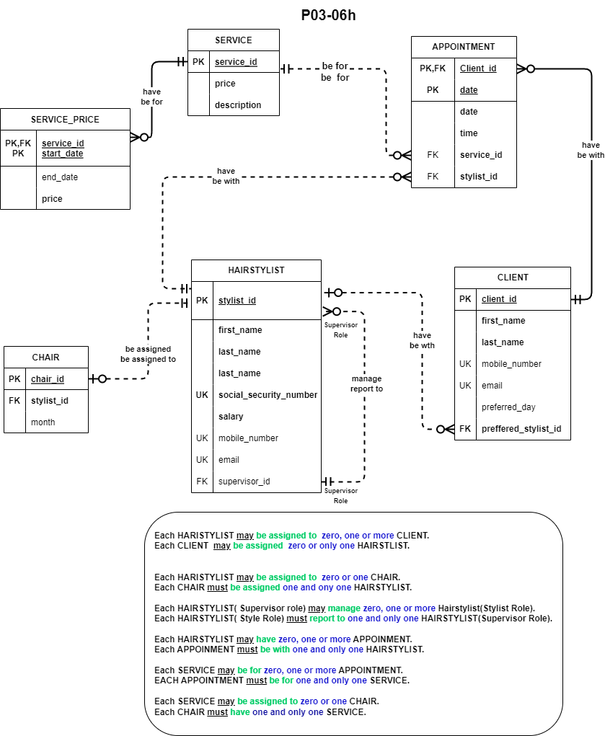

# **Relational Database table of P0602**

|  |  |  |  |  |  |
| --- | --- | --- | --- | --- | --- |
| HAIRSTLIST | | | | | |
| Description | Key Type | Optionality | Column Name | Data Type | Length |
| Hairstylist ID | PK | * | Stylist_id | INTEGER |  |
| Hairstylist First name |  | * | first_name | VARCHAR | 30 |
| Hairstylist Last name |  | * | last_name | VARCHAR | 30 |
| Hairstylist Social Security Number | UK | * | social_security_number | DECIMAL | 9,0 |
| Hairstylist Salary |  | * | Salary | DECIMAL | 7,0 |
| Hairstylist Mobile Number | UK | 0 | mobile_number | VARCHAR | 15 |
| Hairstylist Email | UK | 0 | Email | VARCHAR | 255 |
| Hairstylist Supervisor ID | FK | * | supervisor_id | INTEGER |  |
|  | | | | | |
| CLIENT | | | | | |
| Description | Key Type | Optionality | Column Name | Data Type | Length |
| Client ID | PK | * | client_id | INTEGER |  |
| Client First Name |  | * | first_name | VARCHAR | 30 |
| Client Last name |  | * | last_name | VARCHAR | 30 |
| Client Mobile Number | UK | 0 | mobile_number | VARCHAR | 15 |
| Client Email | UK | 0 | email | VARCHAR | 255 |
| Client’s Preferred Day |  | 0 | preferred_day | VARCHAR | 10 |
| Client’s Preferred Hairstylist ID Person | FK | * | preffered_stylist_id | INTEGER |  |
|  | | | | | |
| CHAIR | | | | | |
| Description | Key Type | Optionality | Column Name | Data Type | Length |
| Chair Assigned ID | PK | * | chair_id | INTEGER |  |
| Hairstylist ID | FK | * | stylist_id | INTEGER |  |
| Recorded Month |  | 0 | Month | DATE |  |
|  | | | | | |
| APPOINTMENT | | | | | |
| Description | Key Type | Optionality | Column Name | Data Type | Length |
| Client ID | PK, FK | * | client_id | INTEGER |  |
| Client Date | PK | * | date | DATE |  |
| Client Appointment Time |  | * | time | TIME |  |
| Service ID | FK | * | service_id | INTEGER |  |
| Hairstylist ID | FK | * | stylist_id | INTEGER |  |
|  | | | | | |
| SERVICE | | | | | |
| Description | Key Type | Optionality | Column Name | Data Type | Length |
| Service ID | PK | * | service_id | INTEGER |  |
| Service Price |  | * | price | DECIMAL | 4,2 |
| Service Description |  | * | description | VARCHAR | 255 |
|  | | | | | |
| SERVICE_PRICE | | | | | |
| Description | Key Type | Optionality | Column Name | Data Type | Length |
| Service ID | PK, FK | * | service_id | INTEGER |  |
| Start Date | PK | * | start_date | DATE |  |
| End Date |  | 0 | start_date | DATE |  |
| Service Price |  | * | price | DECIMAL | 4,2 |

Foreign Key Relationship Mapping

**HAIRSTYLIST**

FK *supervisor_id* >> Supervisor Role

**CLIENT**

FK *prefeered_stylist_id* >> HAIRSTYLIST

**CHAIR**

FK *stylist_id* >> HAIRSTYLIST

**APPOINTMENT**

FK *client_id* >> CLIENT

FK *service_id* >> SERVICE

FK *stylist_id* >> HAIRTSTYLIST

**SERVICE_PRICE**

FK *service_id* >> SERVICE